#### [1tly](https://www.rcsb.org/structure/1TLY) (3.01Å) (E.Coli strain K12),

#### ([TSX](https://www.rcsb.org/groups/sequence/polymer_entity/P0A927)) Nucleoside-specific channel-forming protein

#### Location 9-275aa(294aa)

**Align Executive: RMSD =**  0.211 (1787 to 1787 atoms)

**Align Native and ss H, QTY and ss H, cycles=0,**

**Executive: RMSD** = 0.111 (10 to 10 atoms)

Superimposed Native and QTY varient

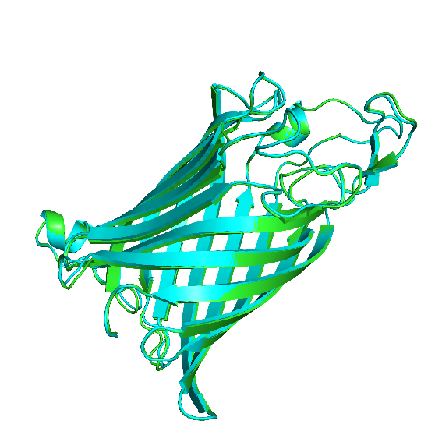 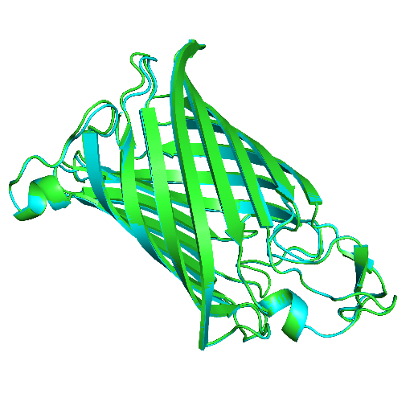

X-180 Rotation

X-90 Rotation

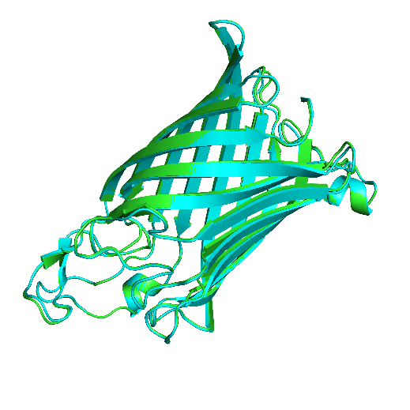

Y-180 Rotation

**ChimeraX 1.4 software for hydrophobic nature of 1tly Nucleoside-specific channel-forming protein-** [**Escherichia coli (strain K12)**](https://www.uniprot.org/taxonomy/83333)

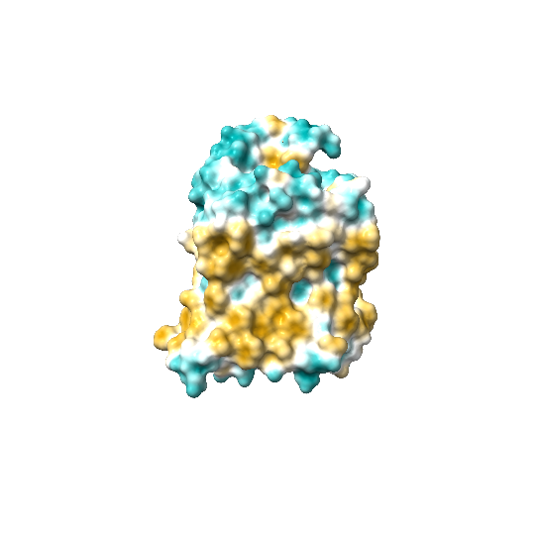 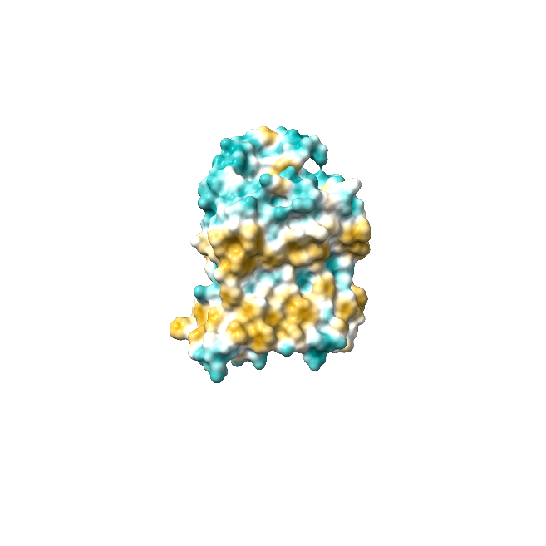

1. Native 1tly (b) QTY variant 1tly**QTY**

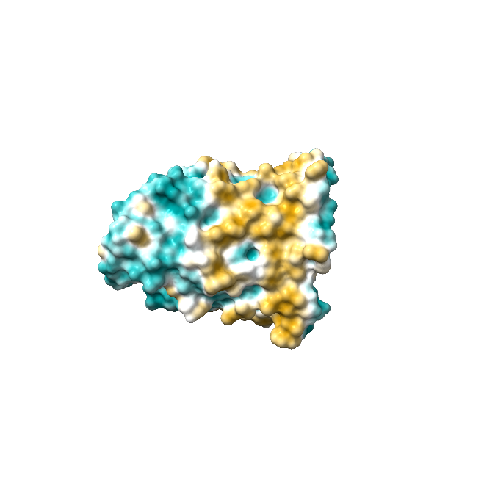 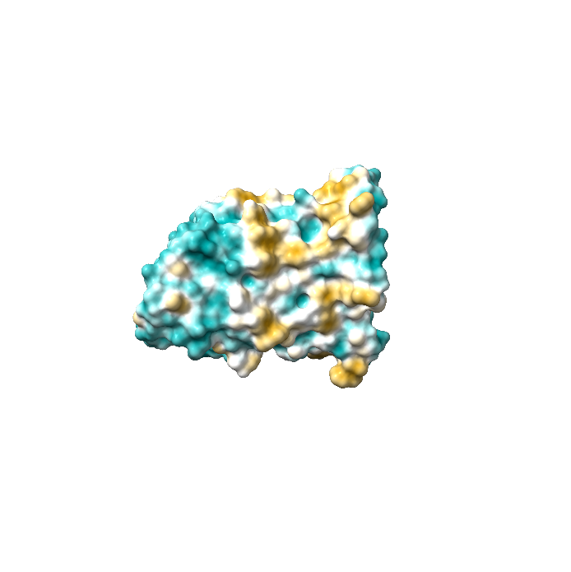

1. Native 1tly (d) QTY variant 1tly**QTY**

Fig1: TSX (E.Coli strain K12), P0A927, TSX ECOLI Amino acids from 9-275aa (294aa) , Nucleoside-specific channel-forming protein.

Akash S S, BSMS chemistry, Indian institute of science education and research, Tirupati.

Jiqing Ye[1](https://pubmed.ncbi.nlm.nih.gov/15272310/#affiliation-1), Bert van den Berg.

[Crystal structure of the bacterial nucleoside transporter Tsx](https://pubmed.ncbi.nlm.nih.gov/15272310/)